EIT OPENS 16 INNOVation hubs across Europe To TACKLE regional INNOVATION DIVIDE

Budapest, Hungary 28 November 2024 - The European Institute of Innovation and Technology (EIT) has successfully launched 16 innovation hubs across Central, Eastern and Southern Europe dedicated to tackling Europe’s regional innovation divide. The new hubs, known as EIT Community Hubs are an integral part of the EIT Regional Innovation Scheme and have been launched in the following countries: Bulgaria, Croatia, Cyprus, Czechia, Estonia , Hungary, Italy, Latvia, Malta, Montenegro, North Macedonia, Slovenia, Türkiye, Ukraine, and Spain and Portugal covering their respective EU’s Outermost Regions.

The new EIT Community Hubs will serve as a central gateway to Europe’s largest innovation ecosystem supporting local innovators and entrepreneurs to scale their innovations and launch new products to the market. EIT Community Hubs represents all EIT Knowledge and Innovation Communities (KICs) under one roof, boosting cooperation among local businesses, education authorities, and research organisations, enhancing the region’s competitiveness and contributing to Europe’s economic growth and competitiveness.

Stefan Dobrev, Chairman of the EIT Governing Board said:
“The EIT Regional Innovation Scheme has grown in the past ten years to be one of the most successful innovation instruments connecting and collaborating, between researchers, entrepreneurs and companies in the widening countries. RIS-eligible countries currently account for 60% of the EIT’s total participation, well above the Horizon Europe average of 40% – and many RIS-supported ventures have realised their potential and found breakthrough commercial success. This year we celebrate ten years of impact, ten years of helping grow companies and launching new innovations to the market”

By connecting regional actors, innovators, and partners to Europe’s largest innovation ecosystem, the EIT RIS strengthens ecosystems in low-innovation performance countries’ ability to innovate and paves the way for synergies between new networks and local and regional smart specialisation strategies.

A DECADE OF IMPACT

2024 marks ten years of impact for the EIT Regional Innovation Scheme – a dedicated programme offering tailor made support and widened regional outreach to ‘moderate’ and ‘emerging’ innovator countries as designated by the European Innovation Scoreboard.

Today, the EIT, under Horizon Europe is strongly addressing Europe’s innovation divide, having invested over one billion euros into building up innovation ecosystems across Europe. Over 700 innovation projects have been supported by the EIT Reginal Innovation Scheme, helping to launch over 500 products and services to the market, and supporting over 3 360 start-ups and scale-up including creating over 250 new start-ups. The EIT Regional Innovation Scheme’s mid-term evaluation results were recently published, documenting the programme’s effectiveness in strengthening the capacity of innovation enablers and actors, such as business accelerators, incubators, start-ups, scale-ups, SMEs, and educational and research institutions. The study also notes that results achieved by the EIT RIS often exceed expectations and highlight the interconnected approach of the EIT Model and the EIT’s local presence as critical to its effectiveness. critical to its effectiveness.

Discover EIT RIS Success Stories Here

In addition to the sixteen established EIT Community Hubs, further innovation hubs will be in launched in the following countries: Albania, Bosnia and Herzegovina, Poland, Romania, Slovakia, Serbia, and France representing the EU’s Outermost Regions by the end of 2025.

JOIN US ONLINE to Discover 10 years of the EIT RIS and JUMPSTARTER GRAND FINALE

EIT - MAKING INNOVATION HAPPEN!

About THE EUROPEAN INSTITUTE OF INNOVATION AND TECHNOLOGY (EIT)

The EIT strengthens Europe’s ability to innovate by powering solutions to pressing global challenges and by nurturing entrepreneurial talent to create sustainable growth and skilled jobs in Europe. The EIT is an EU body and an integral part of Horizon Europe, the EU Framework Programme for Research and Innovation.

The Institute supports dynamic pan-European partnerships, EIT Knowledge and Innovation Communities, among leading companies, research labs and universities. Currently nine EIT Knowledge & Innovation Communities are supported: EIT Climate-KIC, EIT Digital, EIT InnoEnergy, EIT Health, EIT RawMaterials, EIT Food, EIT Manufacturing, EIT Urban Mobility and the newest addition: EIT Culture & Creativity). Together with their leading partners, the EIT Community offers a wide range of innovation and entrepreneurship activities across Europe: entrepreneurial education courses, business creation and acceleration services and innovation driven research projects.
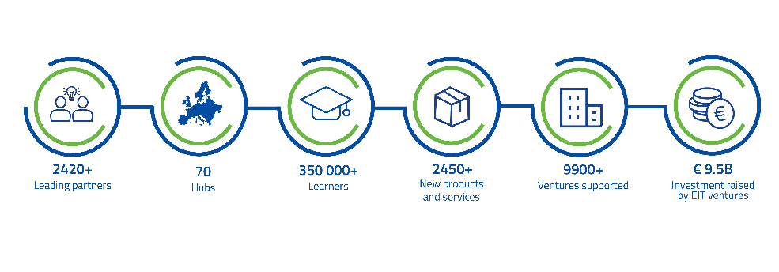

Stay TUNED FOR EIT WATER

The EIT continues to grow with its tenth Knowledge and Innovation Community (KIC) in the field of water, marine and maritime sectors and ecosystems. The new KIC will steer innovation to tackle water scarcity, droughts, floods, and marine and freshwater degradation. It will connect thematic partners to Europe’s largest innovation ecosystem, strengthening the blue economy and Europe’s competitiveness. The Call for Proposals for the new KIC will be published in 2025 and the designated EIT KIC will be launched in 2026. You can find more information related to EIT Water and the timeline here.

